**MARIES STOPES CLINIC, SYLHET**

We the 3rd year MBBS students (SWMC - 12th) of Sylhet Women's Medical College have visited Maries Stopes Clinic on 1st November 2018 under the guidance of Community Medicine. Maries Stopes Clinic is in Sylhet Sadar at Darshan Dewri, Amberkhana opposite of Housing Estate Gate. The clinic was established in the year 1991 AD and is affiliated with Marie Stopes International (MSI) which delivers quality family planning, safe motherhood, sexual and reproductive health services to the people. It provides outdoor services and diagnostic services.

**Date of visit : 1st November 2018**

**Name of organization : Maries Stopes Clinic, Sylhet**

**Location : Darshan Dewri, Amberkhana, Sylhet**

**Year of Establishment : 1991 AD**

**Objectives of visiting Maries Stopes Clinic**

1) To see the services rendered by Maries Stopes Clinic.

2) Staff Pattern and Infrastructure of the clinic.

3) To observe the most frequent cases prevailing in the Sylhet.

**SERVICES PROVISION**

1. Outdoor Patient Department (OPD)

2. Diagnostic Services

**OUTDOOR ATTENDANCE:** About 35-40 patients attending at the Out Patient Department daily on an average.

**MISSION:**

Children by choice, not chance.

**VISION:**

A world in which every birth is wanted and safe.

**STAFFING PATTERN**

|  |  |  |
| --- | --- | --- |
| SERIAL NUMBER | DESIGNATION | NUMBER |
| 1 | Doctor | 2 |
| 2 | Counseller | 1 |
| 3 | Medical Assistant | 2 |
| 4 | Lab Technician | 1 |
| 5 | Accountant | 1 |
| 6 | Sweeper | 1 |

**SERVICES AVAILABLE:** 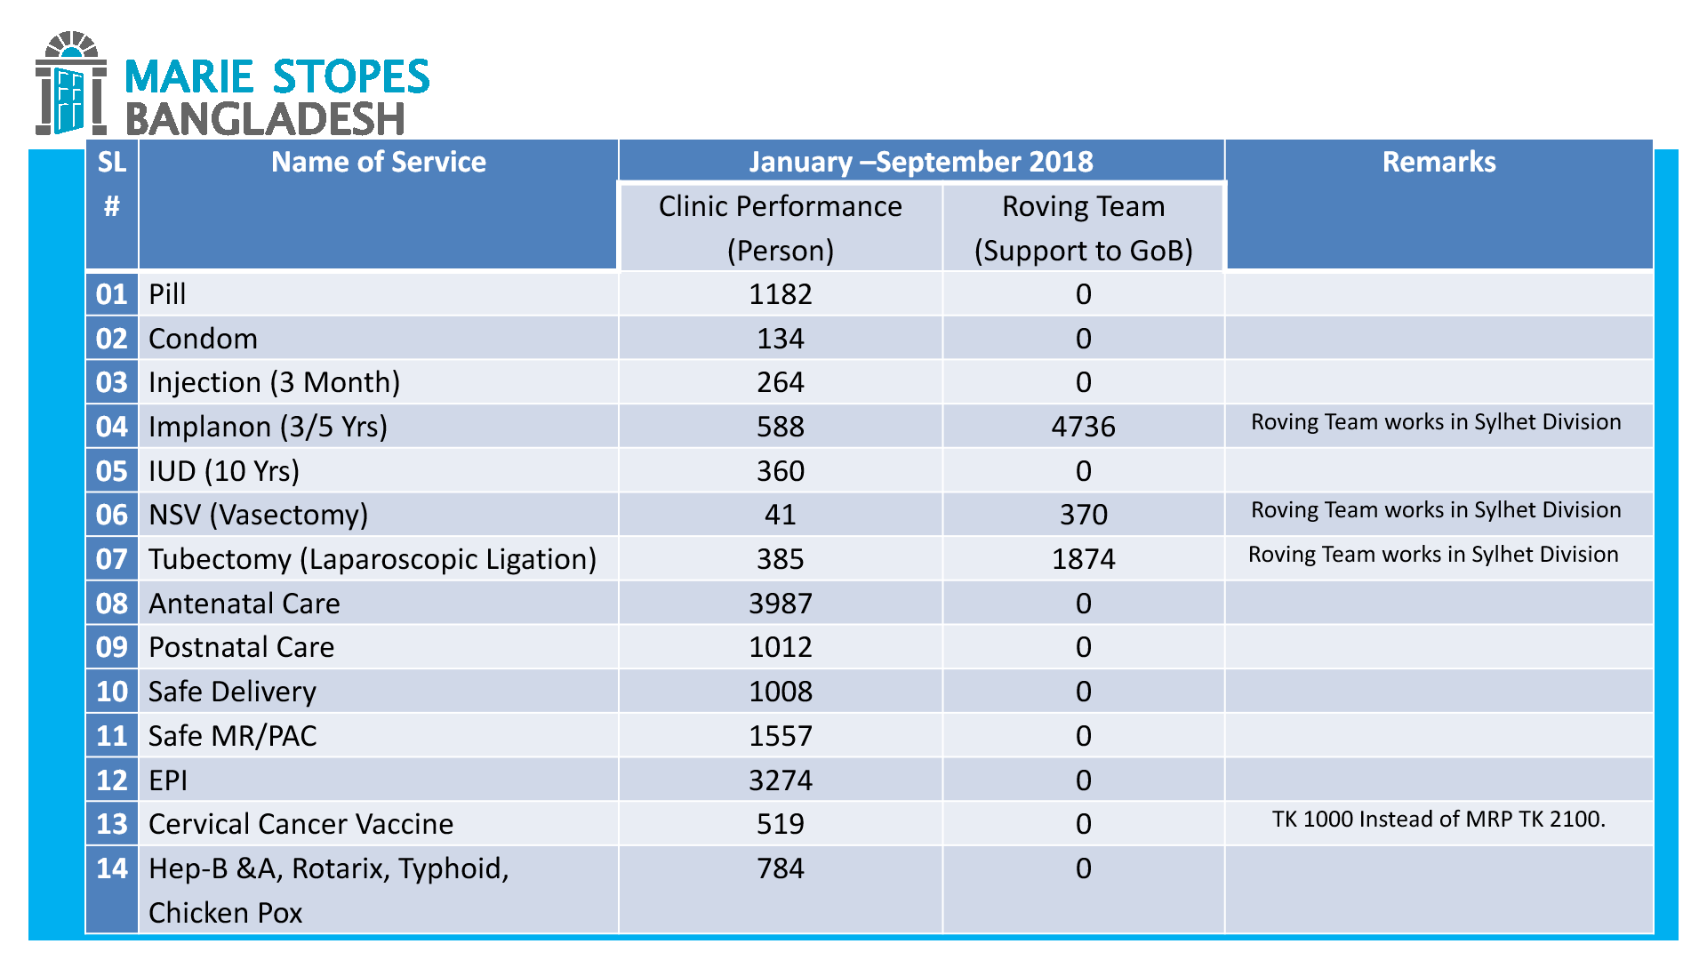

* **Family planning:**

1. Family planning counseling

2. Oral pill

3. Emergency Contraceptive pill (ECP)

4. condom

5. Injection - (3 months)

6. Implanon - (Insertion/Remove) - 3/5 yrs

7. ICD - (Insertion/Remove) -10 yrs

8. NSV (Vasectomy)

9. Tubectomy (Laparoscopic)

10. Safe MR/PAC services

**Safe Motherhood:**

1. Antenatal Care (ANC)

2. Postnatal Care (PNC)

**Reproductive Health:**

1. Reproductive Health Services (RH)

2. Reproductive Tract Infection (RTI)

3. Sexually Transmitted Infections (STI)

**Other Health Services**

1. General Health Services (GH)

2. Child Health (CH)

3. VIA Test (screening)

4. Cryo Therapy

**Patholology:**

1. Blood Grouping

2. HB%

3. Urine Sugar Albumin PH

4. Blood Sugar

5. HBsAg

6. Syphillis Test

7. Ultrasonography

* **Vaccination:**

1. Expanded Programme of Immunization (EPI)

2. Hepatitis-B

3. Typhoid vaccine

4. Cervical Cancer

5. Chicken Pox

6. Rotavirus

7. Measles Mumps Rubella

8. Pneumonia

**Personal Observation**

1. There was around 15-20 beds in the clinic.
2. cleanliness of clinic is good.
3. working environment is satisfactory.

**FAMILY PLANNING**

A way of thinking and living that is adopted voluntarily, upon the basis of knowledge, attitudes and responsible decision by individuals and couples, in order to promote the health and welfare of the family group and thus contribute effectively to the social development of a country.

**CONTRACEPTIVE METHODS:**

The Preventive methods which help to avoid unwanted pregnancy

**CLASSIFICATION**

**1. SPACING METHODS:**

**a. Barrier methods:**

* Physical : condom, diaphragm, vaginal sponge
* Chemical : Foam, cream &pastes, jelly, suppository, soluble film
* Combined : condom+jelly, condom+cream

**b. Intrauterine devices:**

* Non medicated (1st generation) IUCDs : Lippes Loop
* Medicated IUCDs:
* 2nd generation : Cu-T-200, Cu-T-220 C, nova-T
* 3rd generation : progestasert

**c. Hormonal methods:**

* Oral pill:
* Combined Pill : Oestrogen & Progesterone
* Once a month pill
* Progesterone Only Pill
* Male Pill
* Depot formulation:
* DMPA (Depot Medroxy Progesterone Acetate) Intramuscular 150 mg every 3 months
* NET-EN (Norethisterone Enantate) Intramuscular 200 mg every 2 months

**d. Post conceptional methods:**

* Menstrual Regulation (MR)
* Menstrual Induction (MI)
* Abortion

**2. PERMANENT METHODS:**

* Male sterilization: Vasectomy
* Female sterilization : Tubectomy, Tubal ligation

**BARRIER METHODS**

**( CONDOM)**

**Advantages of condom:**

1. They are easily available.
2. Safe and inexpensive.
3. Easy to use and do not require medical supervision.
4. No side effect.
5. Light, compact and disposable.
6. Provides protection not only against pregnancy but also against STDs.

**Disadvantages of condom:**

1. It may slip off or tear during coitus due to incorrect use.
2. Interferes with sex sensation.

* Condom Failure Rate: 2-18%

**IUCD(Intrauterine Contraceptive Device)**

**(COPPER-T)**

It is effective for 5-10 years depends upon manufacture.

**Advantages of Copper-T:**

1. Simplicity
2. Insertion takes only a few minutes.
3. once inserted, stays in place as long as required.
4. Inexpensive
5. Contraceptive effect is reversible by removal of IUCD.
6. Free of systematic metabolic side effects and highest continuation rate.

**Disadvantages of Copper-T:**

1. Bleeding
2. Pain
3. Pelvic infection
4. Uterine perforation
5. Ectopic pregnancy
6. Expulsion
7. Cancer and Teratogenesis

**HORMONAL METHODS**

**(Combined Oral Pill)**

Combined Oral Pill is 100% effective in preventing pregnancy

**Advantages of Combined Oral Pill:**

1. Very effective when used correctly.
2. No need to use any thing at the time of sexual intercourse.
3. Can be used as long as the women needs to prevent the pregnancy.

**Disadvantages of Combined Oral Pill:**

1. **Cardiovascular effect:** Myocardial infarction, cerebral thrombosis
2. **Cancer**
3. **Metabolic effect:** The elevation of Blood Pressure, alternation of serum lipid
4. **Other adverse effect:** Liver disorder (hepatocellular adenoma & gallbladder diseases), subsequent fertility
5. **Common unwanted effect** : Breast tenderness, weight gain

**Maries Stopes also provides the services of safe motherhood:**

1. Antenatal Care (ANC)
2. Postnatal Care (PNC)

**Antenatal Care (ANC)**

Antenatal Care is the of the women during pregnancy.

**objectives of Antenatal Care:**

* To promote, protect and maintain the health of the mother during pregnancy.
* To detect "high risk" cases and give them special attention.
* To foresee complications and prevent them.
* To remove maternal and infant mortality and morbidity.
* To teach the mother elements of child care, nutrition, personal hygiene and environmental sanitation.

**Postnatal Care (PNC)**

Care of the mother and the newborn after delivery is known as Postnatal care.

**Objectives of Postnatal Care:**

* To prevent complications of the postnatal period.
* To provide care for the rapid restoration of the mother to optimum health.
* To check adequacy of breast feeding.
* To provide family planning services.
* to provide basic health education to mother/family.

**Conclusion:**

The visit to Maries Stopes Clinic was very much helpful to us. The organization has been playing very important role in providing preventive, promotive and curative health services chiefly the family planning, safe motherhood & reproductive health. We believe that such type of community approach will enable the people to utilize the services confined to them in order to maintain reproductive, maternal and child health care.